What is Monitoring, Evaluation and Learning in Project Management?

Project monitoring is a mandatory phase for any project manager. Keeping stakeholders up to date on progress and team performance through reports and on-going documentation contributes to project success. Regularly assessing progress related to scope, benchmark goals, timeline, and budget helps to ensure that there are no unpleasant surprises as the project unfolds.

**Project Evaluation:**

Project evaluation is a process of collecting, recording and organizing information about project results and lessons learned for future projects which are captured during the Closure phase.

**Importance of Project Monitoring and Evaluation:**

* Provides the only consolidated source of information showcasing project progress;
* It allows actors to learn from each other’s experiences, building on expertise and knowledge;
* It often generates (written) reports that contribute to transparency and accountability, and allows for lessons to be shared more easily;
* It reveals mistakes and offers paths for learning and improvements;
* It provides a basis for questioning and testing assumptions;
* It provides a means for agencies seeking to learn from their experiences and to incorporate them into policy and practice;
* It provides a way to assess the crucial link between implementers and beneficiaries on the ground and decision-makers;
* It adds to the retention and development of institutional memory;
* It provides a more robust basis for raising funds and influencing policy.

**A step-by-step guide to project monitoring**

Managing a single task is straightforward enough — you put in the work and submit it for review when it’s finished.

In reality, a typical project consists of many moving parts that must work together to meet deadlines. Just one part breaking down can cause delays and financial losses.

Keeping everything on the right track isn’t easy. This is why every project needs to have a system in place to monitor and evaluate its progress.

It sounds obvious enough, but how do you actually do it?

In this article, we’ll provide an in-depth look at what project monitoring and evaluation is, why it’s important, and how to implement it in your organization. We’ll also give you an actionable template you can customize and put what you’ve learned into practice.

**What is project monitoring and evaluation?**

*Project monitoring and evaluation is used to measure a project’s progress. It’s important because it lets you keep tabs on a project and identify potential problems.*

Let’s take a closer look at these two concepts.

**What is project monitoring?**

Project monitoring is the process of keeping a close eye on the entire project management life cycle and ensuring project activities are on the right track.

[**The success of a project depends on a clearly defined structure. Not having a plan would be like building a house without a blueprint — possible, but incredibly difficult with tons of room for error.**](https://twitter.com/intent/tweet?text=The%20success%20of%20a%20project%20depends%20on%20a%20clearly%20defined%20structure.%20Not%20having%20a%20plan%20would%20be%20like%20building%20a%20house%20without%20a%20blueprint%20%E2%80%94%20possible%2C%20but%20incredibly%20difficult%20with%20tons%20of%20room%20for%20error.&url=https://monday.com/blog/project-management/project-monitoring-and-evaluation/)

A lack of goals and measurable objectives ([37%](https://www.pmi.org/-/media/pmi/documents/public/pdf/learning/thought-leadership/pulse/pulse-of-the-profession-2017.pdf)) is the primary reason why projects fail.

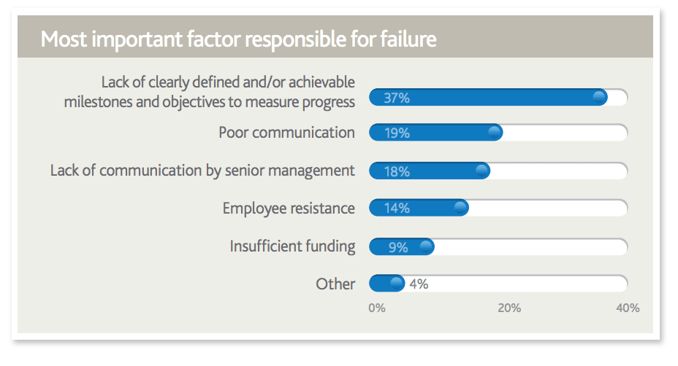

Goals are important for any project because they act as a guide. But just setting an objective isn’t enough. You need to make it a point to check if you’re actually meeting them.

Project monitoring is all about comparing actual performance to the goals you set. If you’re not hitting milestones (e.g., delivering a prototype within a specified time), the project has a high chance of failure.

A project can be divided into five phases: Initiating, Planning, Executing, Closing, and Monitoring and Control.

Let’s take a closer look at each of these phases:

* **Initiation:** The [project initiation phase](https://monday.com/blog/project-management/ready-set-go-project-initiation-the-first-phase-of-project-management/) outlines the steps and processes that must be approved before any planning begins.
* **Planning:** The [project planning phase](https://monday.com/blog/project-management/project-planning-process/) determines the project scope and details the processes for the execution phase.
* **Executing:** The [project execution phase](https://monday.com/blog/project-management/project-execution-the-key-to-successful-projects/) involves carrying out the activities defined in the planning phase.
* **Closing:** The [project closeout](https://monday.com/blog/project-management/project-closeout/) phase finalizes the project and its completion is communicated to all stakeholders.
* **Monitoring and control:** The monitoring and control phase involves making sure the project is on track and incorporating any necessary changes. This happens at the same time as the planning and execution phases.

Project monitoring is the ‘monitoring part’ of the monitoring and control phase.

It involves measuring project-related details (e.g., budgets, schedules, scope, etc.) against your goals to ensure you’re on the right track.

Now let’s take a look at project evaluation.

**What is project evaluation?**

Project evaluation is the ‘control’ part of the monitoring and control phase. It involves looking at the information you gather from monitoring and making decisions based on it (e.g., do we need to adjust schedules or fast track certain processes to meet deadlines?).

Not every project goes according to plan. Costs might exceed the initial budget, team members might miss their deadlines due to [scope creep](https://monday.com/blog/project-management/keep-scope-creep-undermining-project/), a stakeholder may suddenly back out, etc.

But project issues are also perfect learning opportunities to identify where things in the [project plan](https://monday.com/blog/project-management/how-to-write-a-killer-project-plan-in-6-simple-steps/) started to go awry.

This is what a project evaluation framework is all about. Evaluating why a project is heading off course allows time for intervention.

Best case, you discover an issue early enough to get back on course. Worst case, you gain valuable insights that you can use to improve future workflows.

The evaluation process happens throughout the project — not just after [project objectives](https://monday.com/blog/project-management/effective-project-objectives-how-to-define-and-achieve-success/) are met. There may also be more in-depth evaluations at big milestones, like the [retrospective](https://monday.com/blog/marketing/agile-meetings/) at the end of a sprint.

Companies waste an average of [11.4%](https://www.pmi.org/learning/library/forging-future-focused-culture-11908) of their investment on projects due to poor performance. Project monitoring and evaluation is a tool to help you improve a project’s overall efficiency by catching and resolving issues before it’s too late.

Let’s look at how you can get started.

**How to get started with project monitoring and evaluation**

Project monitoring and evaluation enables you to make better decisions about ongoing and future projects. Here’s some framework and steps you can follow to get started.

**#1: Create a plan for monitoring and evaluating your projects**

The first step is to create a process for how you will monitor and evaluate your projects. Start with the following steps:

* **Organize your projects:**You need a platform or system to capture and organize your data in one place. Use [project management software](https://monday.com/) to keep tabs on different phases of a project. Here’s an example of how teams are monitoring the project scope in monday.com:

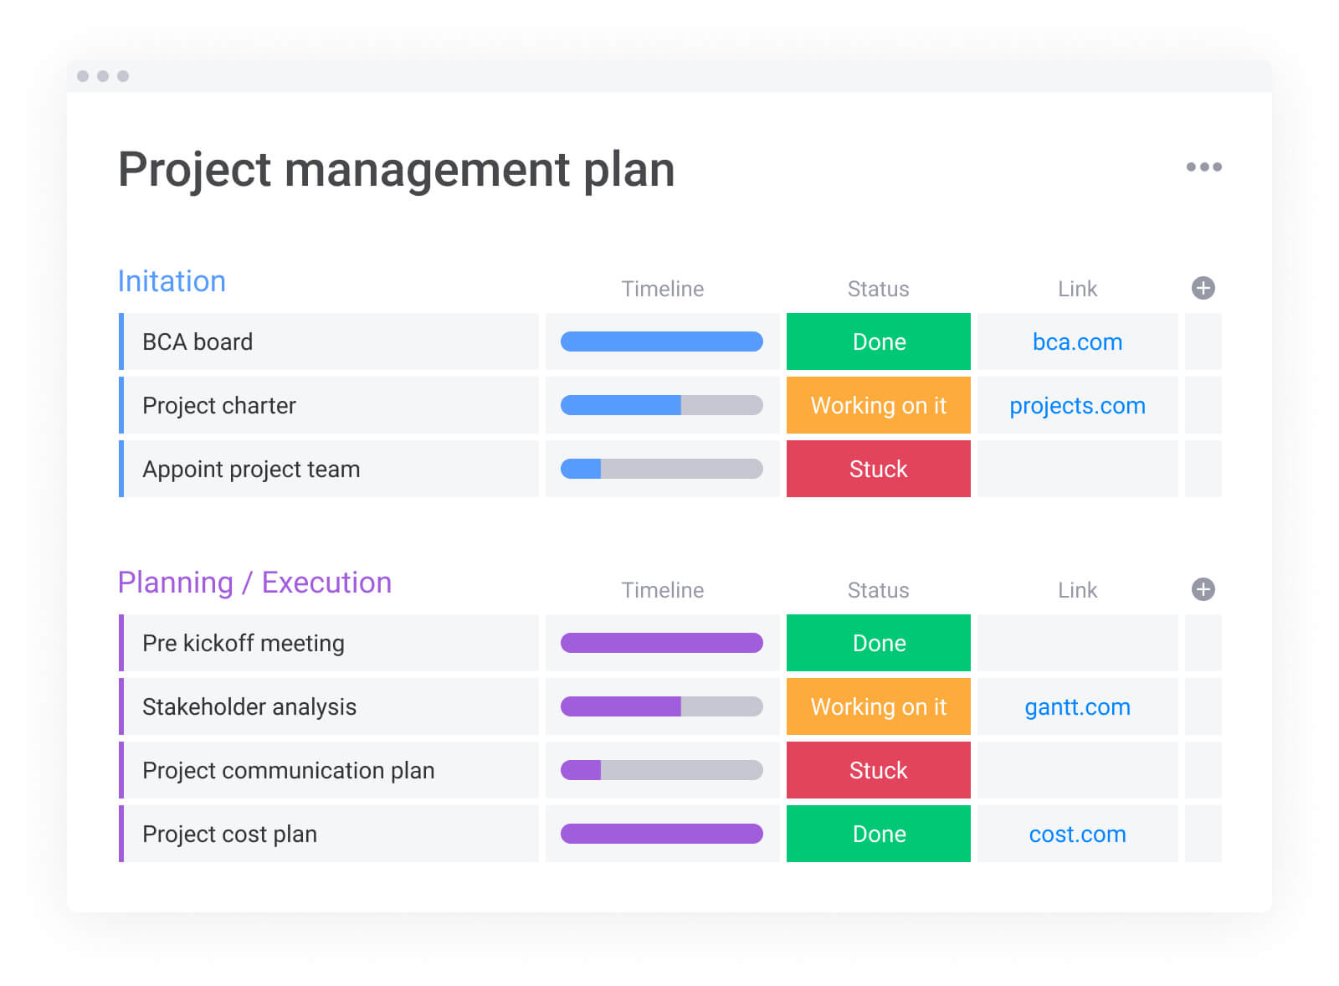

* **Identify responsibilities:** Who will be responsible for monitoring each phase of the project and conducting evaluations? How will they determine and measure project success? Designate stakeholder roles as early as possible and create a checklist of their responsibilities.
* **Record project bottlenecks:**What were some issues that you or your project team experienced? Make sure to record those incidents, including how you addressed them and what the outcome was.
* **Create an evaluation plan:**Will you conduct evaluations every week or after each phase of the project is complete? [Collect feedback](https://www.feedbear.com/collect-feedback) from your team to get their thoughts on how workflows can be improved.

**#2: Monitor performance in real-time**

Whether you’re managing a [construction project](https://monday.com/s/construction-project-management) or launching a new product, you need a real-time view of what’s happening to monitor your projects and make informed decisions.

Here’s an example of how the team at monday.com monitors and manages project implementation in real-time:

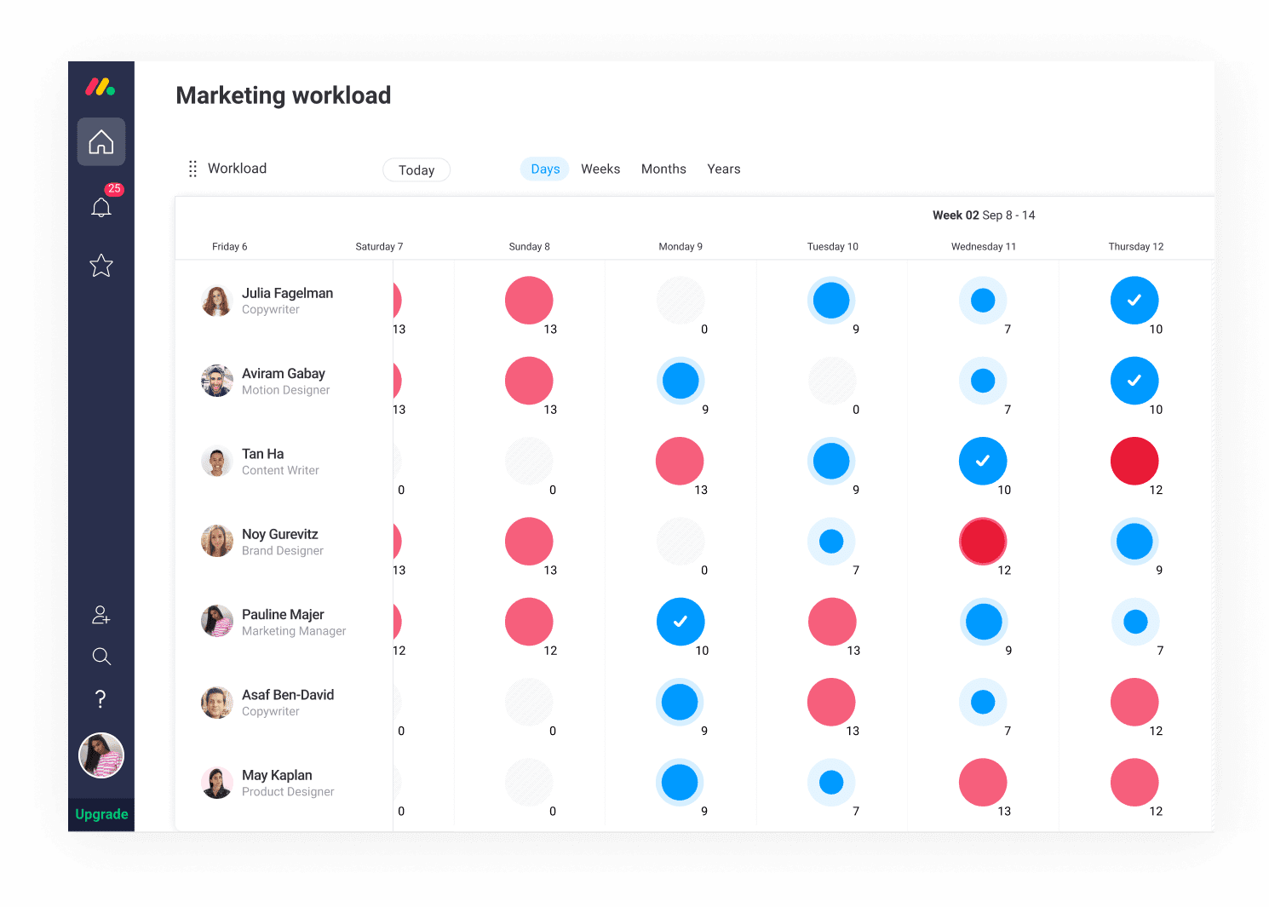

([Image Source](https://monday.com/product/))

Monitoring performance in real-time enables you to track each team member’s progress and allocate resources accordingly.

The last thing you want is to work with outdated information, which is exactly the kind of issue that M Booth, a digital PR agency in New York City, experienced.

Their team was copying and pasting information from [Basecamp](https://monday.com/alternative/basecamp) into a spreadsheet to see everything in one place. But problems arose when one platform was updated and the other wasn’t. This meant that some employees were working with outdated data.

[Click here](https://monday.com/customers/mbooth) to read M Booth’s story and access the template they now use to monitor everything in one place.

**#3: Evaluate project reports**

Was the project delivered on time? Or were there unexpected setbacks?

Answering these questions is what project monitoring and evaluating is all about. But you need to collect the right data and assess the results to find the answers.

Pull reports from an ongoing or completed project and evaluate your key performance indicators (KPIs) — metrics that gauge your project’s performance.

Reviewing reports can help you understand how your team is performing against their goals and pinpoint where timelines started to deviate.

Here’s a quick glance of a project report created in monday.com:

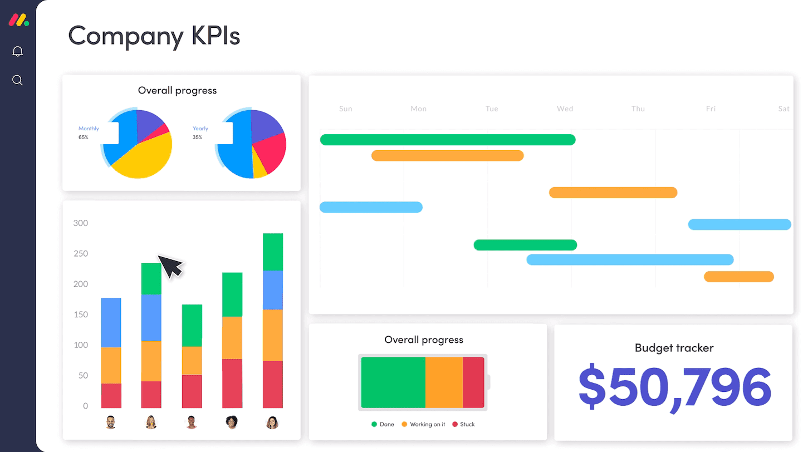

([Image Source](https://monday.com/product/))

**#4: Improve workflow processes**

If a project didn’t meet the deadline, dig deeper to find out why. What were some of the setbacks? How were they eventually resolved?

Don’t stop there though. Use our [incident management template](https://monday.com/templates/incident-management) to record any incidents and how you addressed them.

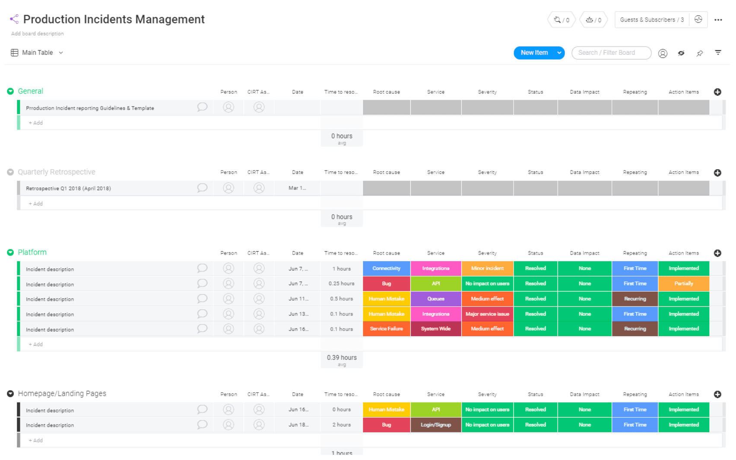

([Image Source](https://monday.com/templates/incident-management))

If anyone on your team runs into a similar issue for future projects, they can refer to the board for a solution.

**#5: Focus on learning and improving**

Project monitoring and evaluation lets you keep tabs on projects, evaluate their progress, and improve processes. Just making one change can have a huge impact on future projects.

For example, the team at monday.com turned hours of tedious meetings into a single 20-minute session just by adding more boards.

But we also recognize there’s always room for improvement, so the team is constantly focusing on learning and improving. That’s the additional reward of project monitoring and evaluation.

Even after implementing a new change, don’t celebrate just yet. Continue learning from and optimizing your evaluation system to make your work processes even more productive.

**Conclusion**

In a perfect world, all of your projects would go according to plan. Everything would be completed on time and within budget.

But that doesn’t always happen in reality — employees may miss deadlines due to personal emergencies, external stakeholders may back out without explanation, etc.

Project monitoring and evaluation enables you to identify and mitigate issues that may impact the project scope, quality, timeline, or budget. You can then take those insights and use them to optimize processes for future projects.

Use this [project tracker template](https://monday.com/templates/project-tracker/) to monitor projects and get a high-level view of where everything stands — all from one place. You can easily customize the template and create a tailored plan that fits your workflow.